1. **Introduction**

**1.1 Objectives**

Our project’s objectives are to spread awareness about SPCA and increasing total number of adoptions. We will solve this by letting the potential adopters interact with the pets, playing with them and getting to know them. We would also like to remove the stigma of people assuming pets are too difficult to take care of, and shying away from adopting a pet.

As seen in Figure.1 below, the number of intakes from shelters are increasing steadily, ranging from owner surrenders to strays. There is only a limited amount of pets shelters can take in, due to manpower and financial constraints. This fuels our passion for this cause.

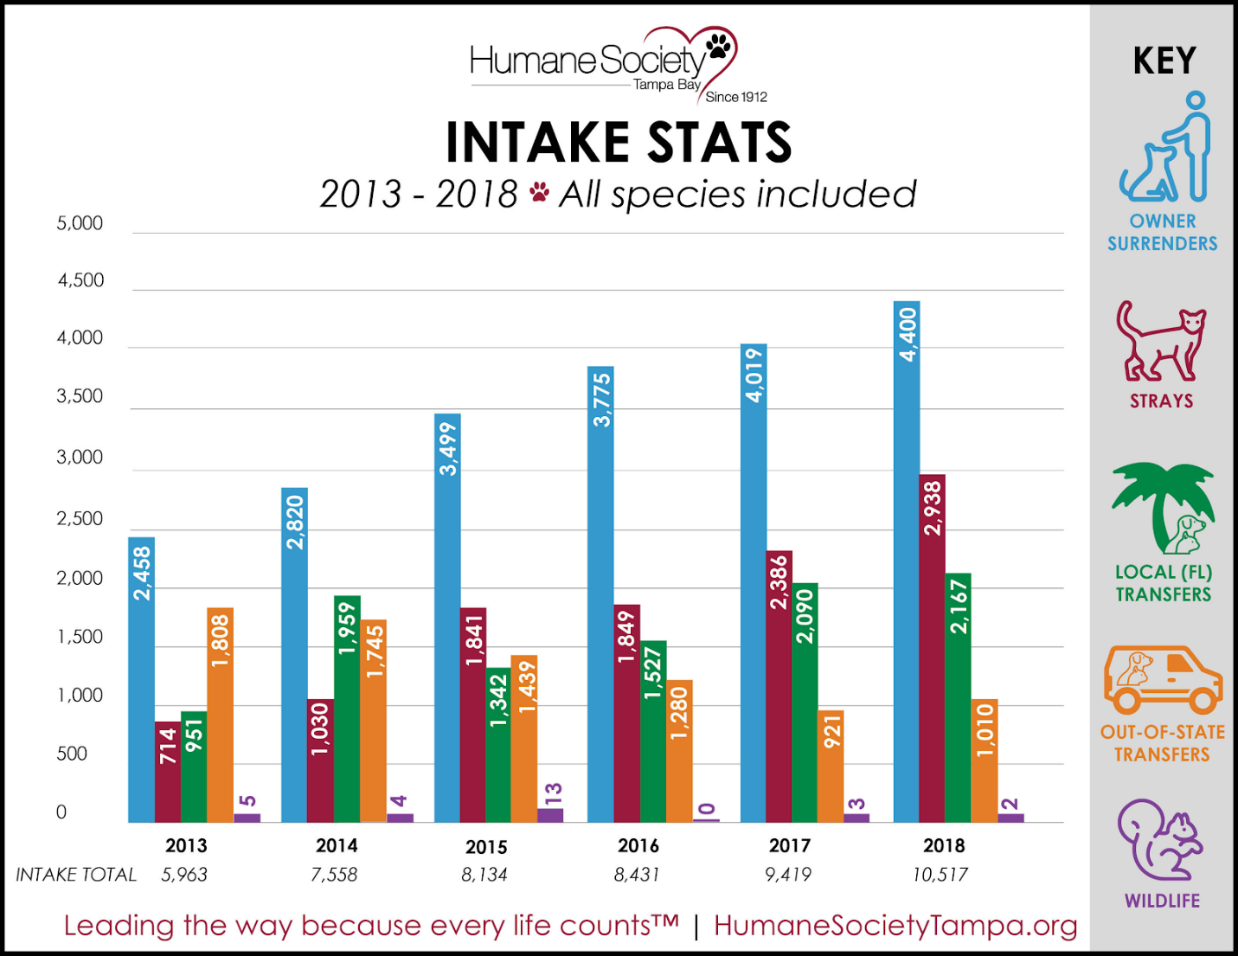

Figure 1: Intake statistics of domestic animals

**1.2 Target Audience**

Our target audiences will be the general public, potential pet owners, children, pet lovers, SPCA. The general public would bring new found interest with the pets, people who already was planning to get a pet would be able to get to know about adoption, Children wanting a pet can finally convince their parents to do so.

**1.3  What is SPCA**

They SPCA stands for The Society for Prevention of Cruelty to Animals. It is a non-government agency and a  registered animal welfare charity. They are a non-government agency,(SPCA stands for The Society for Prevention of Cruelty to Animals. It is a non-government agency and a registered animal welfare charity.) They rely on donations from supporters to sustain themselves. They recieve 100 abandoned pets and stray animals every month. Their objectives are to prevent animal cruelty and to promote kindness towards animals. SPCA’s vision is to have a compassionate singapore where all animals are treated with kindness and respect. Their mission is through education, advocacy and action to prevent animal cruelty and promote kindness. Their ambition is to be the leading authority and advocate on animal welfare and cruelty issues in Singapore. They provide 24 hours emergency animal rescue. Investigate into cases of animal cruelty.

**1.4 Collaboration with SPCA**

We have collaborated with SPCA for this event. However, we plan on helping out and collaborating with more organisations like SOSD, ASD, and more in the future.

We chose SPCA because they are one of the main organisations known in singapore, which will definitely gain the trust of the public, regarding the health of the animals and also the trust to the professionals involved.

1. **Proposed Plan**

**2.1 Purpose of Proposed Plan**

Project: SPCAware aims to gather potential pet owners, pet lovers and Singaporeans at our carnival. The carnival will raise awareness for SPCA by providing information about SPCA from an exhibition booth and information counter about domestic animals. There will also be fun filled family activities.

**2.2 Theme of Carnival**

Our theme for the carnival will be on Pokémon as represents a pet we can play with and help us reduce stress. Many adults childhood are related to Pokémon, which therefore encourages them to bring their kids to the carnival. This can be seen from the Pokémon Safari zone event in Singapore.

**2.3 Layout of Carnival**

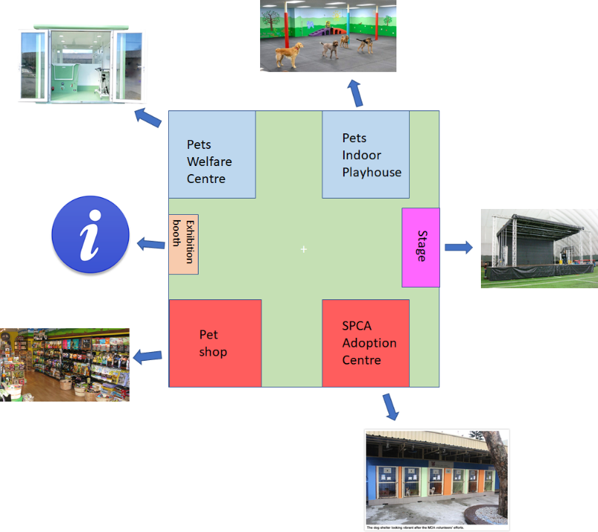

Figure 2: Layout plan for the carnival

Layout will include areas for the following:

* Pets Welfare Centre
* Pets Indoor Playhouse
* Exhibition booth
* Stage for pet performance and ceremony
* SPCA Adoption Centre
* Pet Shop

Each of these areas will hold an activity, which will be explained in the activities section.

**2.4 Activities**

**2.4.1 Pets Welfare Centre**

Owners, professional groomers and veterinarians will be working together to groom their pets ensure their pet is in a healthy condition.  New pet owners will learn proper ways to groom their pets and do healthcare checks. It is important to learn how to groom our pets as it has many benefits like household cleanliness and healthcare check, as seen from the reference below.

**2.4.2 Pets indoor playhouse**

The playhouse allows pets to interact with other humans and meet other animals.Therefore if our dog meets another animal in public, they won’t fight or bark aggressively. New owners can also meet other experienced pet owners, to learn the ropes of taking care of the pet. Interacting with animals can bring about happiness and help us stress relieve, this can be seen from the blog referenced.

**2.4.3 Pet Performance**

There will be a pet performance featuring dogs and cats performing tricks during the carnival. However the twist to this performance is that those animals performing were once from SPCA and now adopted into the hands of a good owner.

From this activity, it may change to mindset of Singaporeans thinking pets from SPCA are unwanted and unfriendly, which is not true. Therefore, this activity will help in raising awareness for SPCA.

**2.4.4 SPCA Adoption Centre**

SPCA adoption centre consist of a few domestic animals for adoption. We will encourage Singaporean to adopt a pet from SPCA instead of buying from a regular pet store. SPCA will also bring a pictures of all their domestic animals they have, this will allow Singaporeans to order the pet and they can collect the pet from SPCA at a later date.

**2.4.5 Pet Shop**

The Pet Shop will include an assortment of products. Packages will be offered to new owners at a lower cost, which will include the necessities of owning a domestic animal, for example, pet food, tray, water dispenser, collars, treats and even more. This will help ease the starting trouble of owning a pet.

**2.4.6 Appreciation Ceremony**

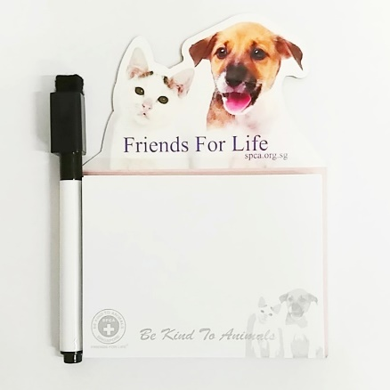

Figure 4: SPCA Notepad    Figure 5: SPCA calendar

Past adopters will be invited to share their story and experience with the visitors. This raises awareness for SPCA and encourages adoption as well.

To express our gratitude for the people who adopted pets, SPCA and us have collaborated together to provide a small token of appreciation for said pet adopters. A professional photoshoot with their pets will also be provided , along with some complimentary SPCA merchandise as keepsake. (Refer to Figure 4 and 5)

1. **Execution of Plan**

The team has thought out crucial components such as the project schedule, location, as well as marketing techniques to increase our outreach. It is also essential to plan out the personnel involved and the potential challenges/problems that may arise.

**3.1 Project Schedule**

|  |  |
| --- | --- |
| Task | Expected Completion Date |
| Pitch to SPCA + Confirmation | 20th May |
| Getting a hold of the venue | 10th April |
| Contacting potential partners and volunteers + Confirmation | 31st April |
| Spreading awareness about the event via flyers/posters/brochures | 1st july |
| Setting up the event area | 2nd July - 5th July |

Table 1: Preparation deadlines

As this is a one time event, the project schedule will include the timing of certain events happening on the day itself, including the preparation needed prior to the event. (Refer to Table 1)

|  |  |
| --- | --- |
| Event | Time |
| First shift arrives and starts setting up | 7 am |
| Fair opens and first arrivals enter | 9 am |
| First shift goes for lunch/Second shift arrives | 1 pm |
| Close up and pack up | 6 pm |

Table 2: Event schedule

On the day itself, there will be two shifts. The first shift is from 7am-6pm, for volunteers who can make it the whole day. For those that are only free in the afternoon, they arrive from 1pm to 6pm, as we expect the afternoon to be more hectic. (Refer to Table 2)

**3.2 Project location**

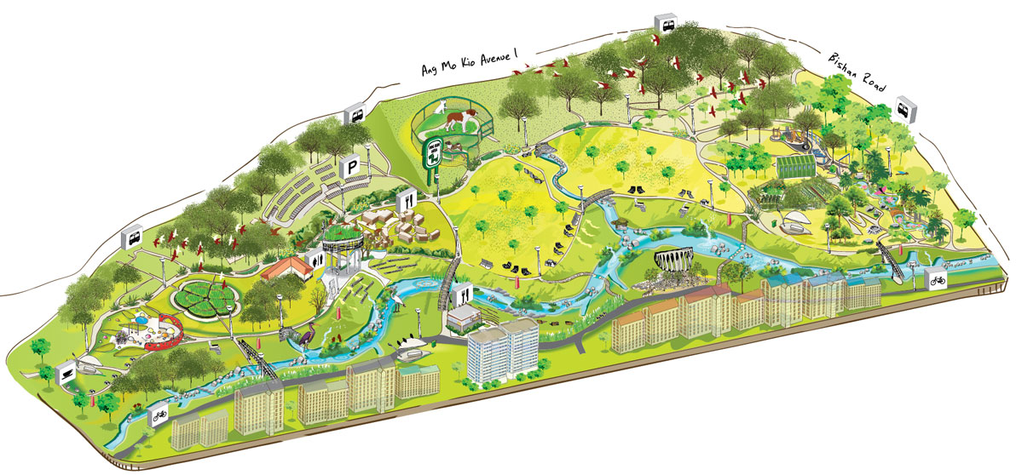

Figure 6: Bishan Park Map

We decided that it would be best to choose the Bishan-Ang Mo Kio Park, located at 1384 Ang Mo Kio Ave 1 as our event venue. (Refer to Figure 6)

Bishan-Ang Mo Kio park was chosen due to its accessibility. Surrounded by multiple bus stops and residential buildings around its perimeter, the park is easily accessed by anyone, resulting in a higher visitor count as well due to the high number of residents nearby. The event location would be the two large patches of grass in the middle, separated by a small lake.

The park has plenty of beautiful greenery and activities for people of all ages to enjoy hence it is frequently visited and attracts a large numbers of visitors daily, which in turn increases our visitor count for the event.

“With open lawns and gently sloping grassy banks along either side of the river, families can have picnics and gatherings while enjoying the beauty and tranquility of the waterways.” (National Parks Board,2019)

**3.3 Marketing**

To increase visitor count,  brochures and flyers will also be given out by us to the general public to spread awareness for the event as brochures contain beautiful images and text that catches the reader’s attention, thus encouraging them to attend the event.

**3.4 Staff Involved**

A professional photographer will be present. Trained SPCA personnel will also be present to take care of the animals present as well as educate the visitors on information like SPCA’s mission, while others demonstrate how to take care/groom certain pets. Volunteers from SPCA and SP will also be present to help out where needed, such as guiding the visitors.

**3.5 Challenges**

There may be too many visitors present in order for us to handle. Furthermore, there is the off chance that none of the visitors are mentally or emotionally ready to adopt a pet as well.

To solve that we have engaged SP students to volunteer to help out with the huge number of visitors. We also have activities in store to help educate potential adopters in order to ease their mind. (Refer to 2.4 Activities)

1. **Budget**

Table 1 shows the estimated cost for hosting the carnival. The total cost for carrying out the carnival is estimated to use $3,000. Other cost involving external companies and the carnival’s manpower will be borne by the company itself and SPCA respectively.

Table 3: Estimated cost of carnival

|  |  |  |  |  |
| --- | --- | --- | --- | --- |
| S/N | Description ( Item) | Qty | Price/ Qty | Sub-Total |
| 1 | Tentage 25mx25m (including transportation and set-up) | 1 day | $1,000 | $1,000 |
| 2 | Booking fee for venue | 1 day | $1,000 | $1,000 |
| 3 | Printing of brochures | 500 pieces | $0.25 | $125 |
| 4 | Printing of exhibition informative walls | - | - | $600 |
| Total: | $2,725 | | | |

1. **Expected Outcome**

During the carnival, we are expecting to receive at least 400 people. Visitors will get a better inside of SPCA’s vision and actions through the interactive activities. Thereafter, we expect to see visitors donating or signing up as volunteers.  Another expected outcome is to see 30 pets being adopted by the end of the carnival. These expected outcomes are inline with our primary objective of spreading SPCA’s awareness and increasing adoption rates.

1. **Benefits**

**6.1 SPCA**

The general public will be more aware about SPCA and its missions through the educational exhibition. This helps to increase the chances of more donations being made people volunteering towards the cause, keeping the organisation running. Adoptions rates will also improve. The visitors at the event may adopt from the carnival directly, or from SPCA itself. This is important adoptions rates has been dropping from 860 adoptions in 2016 to 812 adoption in 2017 and 680 adoption in 2018. (SPCA, 2016,2017,2018). This allows SPCA to rehabilitate more animals and reduce the strain on staffs taking care.

**6.2 Animals**

The pets adopted will also be brought into new homes where they will be loved and cared for by their new owners, thus leading a newer and better life.

**6.3 Pet Owners**

This one stop carnival provides new pet owners with adequate knowledge and tips on how to correctly look after their pets.

1. **Conclusion**

In conclusion, SPCA’s support can be further expanded through this once off event. This support goes a long way in contributing to their cause, creating a better environment for both humans and animals in Singapore.

The carnival will be enjoyed by people of all ages. Through this event, the public will be able to learn more about SPCA as well as donate to the cause

The team is grateful for the collaboration between SPCA and Singapore Polytechnic. We are certain that this event will produce a positive outcome for SPCA.

The team therefore seeks Singapore Polytechnic support for the application of the National Youth Council Young Change Makers Grant.